**From Telusko:**

We use Maven build tool, because we can get the library we need and project structure as well. Adding new library/updating dependencies is easy with this tool too.

In the pom.xml file:

* If we are creating core java application, we would get packaging as **jar**, if we using web application, we would get packaging as **war**.
* In the dependencies section, we add our dependency
* groupID is more like the company name, and artifactID is the project name. They both combine to for the package name.
* Archtype in maven means architecture type.

Creating a Spring MVC app using maven:

* For IntelliJ, we can use Maven and from **archtype**, we can select **webapp**.
* Then, we can create **dispatcher servlet** and its **mapping**. The mapping means any request will go to the dispatcher servlet.

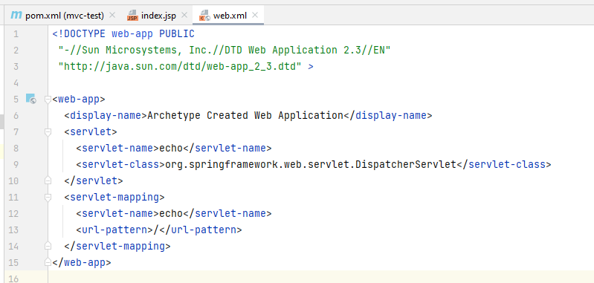

* Then we can add spring and spring mvc dependencies in the pom.xml file.

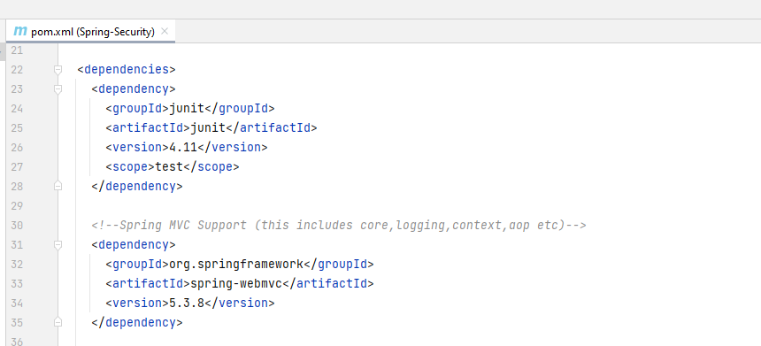

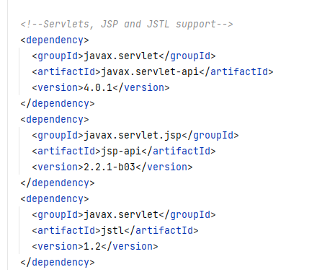

Unfortunately, the version of different projects is not in sync. So, we need to manually check

